Bee Lazi

Software Development Plan (Small Project)

Version <1.0>

Revision History

|  |  |  |  |
| --- | --- | --- | --- |
| **Date** | **Version** | **Description** | **Author** |
| 31/10/2016 | 1.0 | Draft Documentation | Gia-An To |
|  |  |  |  |
|  |  |  |  |
|  |  |  |  |

Table of Contents

1. Introduction 4

2. Project Overview 4

2.1 Project Purpose, Scope, and Objectives 4

2.2 Assumptions and Constraints 4

2.3 Project Deliverables 4

3. Project Organization 4

3.1 Organizational Structure 4

3.2 Roles and Responsibilities 4

4. Management Process 4

4.1 Project Estimates 4

4.2 Project Plan 4

4.2.1 Phase and Iteration Plan 5

4.2.2 Releases 5

4.2.3 Project Schedule 5

4.2.4 Project Resourcing 5

4.3 Project Monitoring and Control 5

4.3.1 Reporting 5

4.3.2 Risk Management 5

4.3.3 Configuration Management 6

Software Development Plan (Small Project)

# Introduction

This document includes detailed project’s plan for our team to stick to, and also make a change, reconsider it throughout the process.

# Project Overview

## Project Purpose, Scope, and Objectives

This project proposes an easy and quick way to help people have more confident in making decisions. A system can be improved through time and provides better suggestions. The product is aimed to lazy and busy people such as the youth, workers, and employees.

## Assumptions and Constraints

* Project has a fixed schedule of 10 weeks
* Zero-budget project
* Project has 5 people, there will be no more people added during the project
* Report the process weekly.
* Complete important feature listed in vision document.

## Project Deliverables

_ High accuracy suggestions with characteristic.

_ Lists of confidential questions.

_ Friendly User Interface.

_ Proper activity schedule.

_ Exciting experience which is suitable for users’ hobbies.

# Project Organization

## Organizational Structure

## Roles and Responsibilities

|  |  |
| --- | --- |
| **Person** | **Role** |
| Tu-Khiem Le, Designer  Quoc-Huu Che, Tester  Manh-Tien Nguyen-Hoang, Van-Tu Ninh, Developer  Gia-An To, Team leader | Design the components, classes, interface.  Write test plan and test cases. Perfom testing.  Write source code, perform unit test, review source code.  Write project plan , monitor and report status, coordinate meetings |

# Management Process

## Project Estimates

10 person-month. Basis for those estimates is the amount of workload for 5 people in approximately 2 months.

## Project Plan

### Phase and Iteration Plan

**_Phase 1: Inception (17/10-30/10)**

+ Iteration 1: Project plan, vision document, weekly report

+ Iteration 2: Detailed vision document, revised project plan, weekly report, initial use case model

**_Phase 2: Elaboration (31/10-20/11)**

+ Iteration 3: Revised project plan, revised vision document, use case document with a revised use case model

+Iteration 4: design document (including UI prototypes, architecture document)

+Iteration 5: Test plan

**_Phase 3: Construction (21/11-18/12)**

+Iteration 6: Revised artifacts submitted in Elaboration.

+Iteration 7: Code and implement main feature.

+Iteration 8: Create test cases, fix defects, and continue to code other feature.

+Iteration 9: Writing test report. Release demo.

**_Phase 4: Transition (19/12-25/12)**

+Iteration 10: Final review. Release alpha version.

### Releases

The software release is a demo with main feature are smart activity suggestion (food, entertainment places) with proper time in user’s schedule, attractive and simple UI. With any suggestion, user only answer yes or no to show their agreement to the suggestions. The application uses the answer to analyze and gives more suitable result to user.

### Project Schedule

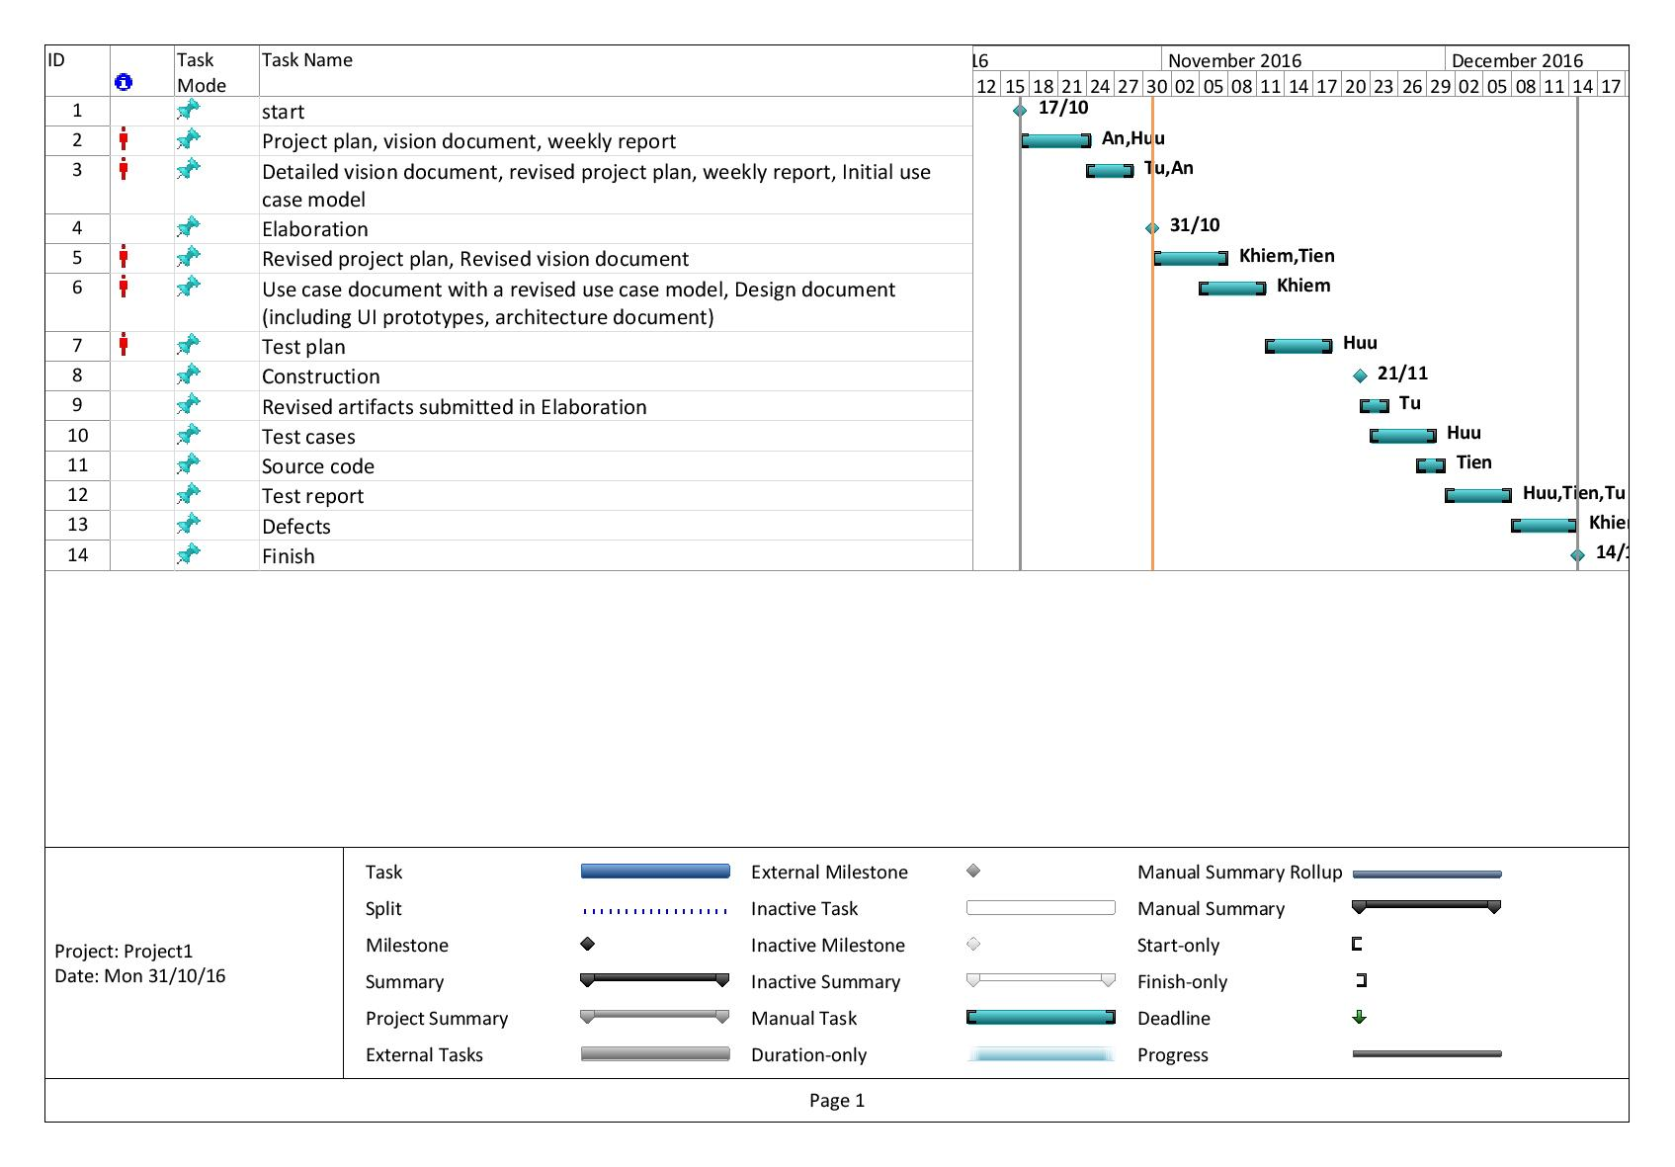

## Project Monitoring and Control

### Reporting

* Weekly meeting
* Weekly status report
* Discussing on Slack
* Trello card updating

### Risk Management

[Identify risks in your project. The risks should be prioritized, and shorted according to their priority.]

|  |  |  |  |  |  |
| --- | --- | --- | --- | --- | --- |
| Risk ID | Risk Description | Probability | Impact | Priority | Mitigation Strategy or Contingency Plan |
|  |  |  |  |  |  |
|  |  |  |  |  |  |
|  |  |  |  |  |  |

### Configuration Management

* Google drive or Dropbox for storing and sharing documents and files.
* Git, Bitbucket for managing source code and related files.
* Slack for communicating with team members
* Trello for task assignment